Decision Tree

Data set
For instance, the following table informs about decision making factors to play tennis at outside for previous 14 days.
Day | Outlook | Temp. | Humidity | Wind | Decision
1 | Sunny | Hot | High | Weak | No
2 | Sunny | Hot | High | Strong | No
3 | Overcast | Hot | High | Weak | Yes
4 | Rain | Mild | High | Weak | Yes
5 | Rain | Cool | Normal | Weak | Yes
6 | Rain | Cool | Normal | Strong | No
7 | Overcast | Cool | Normal | Strong | Yes
8 | Sunny | Mild | High | Weak | No
9 | Sunny | Cool | Normal | Weak | Yes
10 | Rain | Mild | Normal | Weak | Yes
11 | Sunny | Mild | Normal | Strong | Yes
12 | Overcast | Mild | High | Strong | Yes
13 | Overcast | Hot | Normal | Weak | Yes
14 | Rain | Mild | High | Strong | No
We can summarize the ID3 algorithm as illustrated below
Entropy(S) = ∑ – p(I) . log₂p(I)
Gain(S, A) = Entropy(S) – ∑ [ p(S|A) . Entropy(S|A) ]
These formulas might confuse your mind. Practicing will make it understandable.

Entropy
We need to calculate the entropy first. Decision column consists of 14 instances and includes two labels: yes and no. There are 9 decisions labeled yes, and 5 decisions labeled no.
Entropy(Decision) = – p(Yes) . log₂p(Yes) – p(No) . log₂p(No)
Entropy(Decision) = – (9/14) . log₂(9/14) – (5/14) . log₂(5/14) = 0.940
Now, we need to find the most dominant factor for decisioning.

Wind factor on decision
Gain(Decision, Wind) = Entropy(Decision) – ∑ [ p(Decision|Wind) . Entropy(Decision|Wind) ]
Wind attribute has two labels: weak and strong. We would reflect it to the formula.
Gain(Decision, Wind) = Entropy(Decision) – [ p(Decision|Wind=Weak) . Entropy(Decision|Wind=Weak) ] – [ p(Decision|Wind=Strong) . Entropy(Decision|Wind=Strong) ]

Now, we need to calculate (Decision|Wind=Weak) and (Decision|Wind=Strong) respectively.

Weak wind factor on decision
Day | Outlook | Temp. | Humidity | Wind | Decision
1 | Sunny | Hot | High | Weak | No
3 | Overcast | Hot | High | Weak | Yes
4 | Rain | Mild | High | Weak | Yes
5 | Rain | Cool | Normal | Weak | Yes
8 | Sunny | Mild | High | Weak | No
9 | Sunny | Cool | Normal | Weak | Yes
10 | Rain | Mild | Normal | Weak | Yes
13 | Overcast | Hot | Normal | Weak | Yes
There are 8 instances for weak wind. Decision of 2 items are no and 6 items are yes as illustrated below.
1- Entropy(Decision|Wind=Weak) = – p(No) . log₂p(No) – p(Yes) . log₂p(Yes)
2- Entropy(Decision|Wind=Weak) = – (2/8) . log₂(2/8) – (6/8) . log₂(6/8) = 0.811
Notice that if the number of instances of a class were 0 and total number of instances were n, then we need to calculate -(0/n) . log₂(0/n). Here, log(0) would be equal to -∞, and we cannot calculate 0 times ∞. This is a special case often appears in decision tree applications. Even though compilers cannot compute this operation, we can compute it with calculus. If you wonder how to compute this equation, please read this post.

Strong wind factor on decision
Day | Outlook | Temp. | Humidity | Wind | Decision
2 | Sunny | Hot | High | Strong | No
6 | Rain | Cool | Normal | Strong | No
7 | Overcast | Cool | Normal | Strong | Yes
11 | Sunny | Mild | Normal | Strong | Yes
12 | Overcast | Mild | High | Strong | Yes
14 | Rain | Mild | High | Strong | No
Here, there are 6 instances for strong wind. Decision is divided into two equal parts.
1- Entropy(Decision|Wind=Strong) = – p(No) . log₂p(No) – p(Yes) . log₂p(Yes)
2- Entropy(Decision|Wind=Strong) = – (3/6) . log₂(3/6) – (3/6) . log₂(3/6) = 1
Now, we can turn back to Gain(Decision, Wind) equation.
Gain(Decision, Wind) = Entropy(Decision) – [ p(Decision|Wind=Weak) . Entropy(Decision|Wind=Weak) ] – [ p(Decision|Wind=Strong) . Entropy(Decision|Wind=Strong) ] = 0.940 – [ (8/14) . 0.811 ] – [ (6/14). 1] = 0.048
Calculations for wind column is over. Now, we need to apply same calculations for other columns to find the most dominant factor on decision.

Other factors on decision
We have applied similar calculation on the other columns.
1- Gain(Decision, Outlook) = 0.246
2- Gain(Decision, Temperature) = 0.029
3- Gain(Decision, Humidity) = 0.151

As seen, outlook factor on decision produces the highest score. That’s why, outlook decision will appear in the root node of the tree.
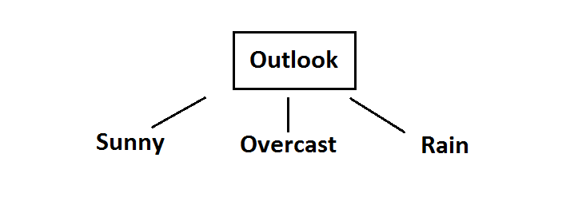Root decision on the tree
Now, we need to test dataset for custom subsets of outlook attribute.

Overcast outlook on decision
Basically, decision will always be yes if outlook were overcast.
Day | Outlook | Temp. | Humidity | Wind | Decision
3 | Overcast | Hot | High | Weak | Yes
7 | Overcast | Cool | Normal | Strong | Yes
12 | Overcast | Mild | High | Strong | Yes
13 | Overcast | Hot | Normal | Weak | Yes

Sunny outlook on decision
Day | Outlook | Temp. | Humidity | Wind | Decision
1 | Sunny | Hot | High | Weak | No
2 | Sunny | Hot | High | Strong | No
8 | Sunny | Mild | High | Weak | No
9 | Sunny | Cool | Normal | Weak | Yes
11 | Sunny | Mild | Normal | Strong | Yes
Here, there are 5 instances for sunny outlook. Decision would be probably 3/5 percent no, 2/5 percent yes.
1- Gain(Outlook=Sunny|Temperature) = 0.570
2- Gain(Outlook=Sunny|Humidity) = 0.970
3- Gain(Outlook=Sunny|Wind) = 0.019
Now, humidity is the decision because it produces the highest score if outlook were sunny.
At this point, decision will always be no if humidity were high.
Day | Outlook | Temp. | Humidity | Wind | Decision
1 | Sunny | Hot | High | Weak | No
2 | Sunny | Hot | High | Strong | No
8 | Sunny | Mild | High | Weak | No
On the other hand, decision will always be yes if humidity were normal
Day | Outlook | Temp. | Humidity | Wind | Decision
9 | Sunny | Cool | Normal | Weak | Yes
11 | Sunny | Mild | Normal | Strong | Yes
Finally, it means that we need to check the humidity and decide if outlook were sunny.

Rain outlook on decision
Day | Outlook | Temp. | Humidity | Wind | Decision
4 | Rain | Mild | High | Weak | Yes
5 | Rain | Cool | Normal | Weak | Yes
6 | Rain | Cool | Normal | Strong | No
10 | Rain | Mild | Normal | Weak | Yes
14 | Rain | Mild | High | Strong | No
1- Gain(Outlook=Rain | Temperature) = 0.01997309402197489
2- Gain(Outlook=Rain | Humidity) = 0.01997309402197489
3- Gain(Outlook=Rain | Wind) = 0.9709505944546686
Here, wind produces the highest score if outlook were rain. That’s why, we need to check wind attribute in 2nd level if outlook were rain.

So, it is revealed that decision will always be yes if wind were weak and outlook were rain.
Day | Outlook | Temp. | Humidity | Wind | Decision
4 | Rain | Mild | High | Weak | Yes
5 | Rain | Cool | Normal | Weak | Yes
10 | Rain | Mild | Normal | Weak | Yes
What’s more, decision will be always no if wind were strong and outlook were rain.
Day | Outlook | Temp. | Humidity | Wind | Decision
6 | Rain | Cool | Normal | Strong | No
14 | Rain | Mild | High | Strong | No
So, decision tree construction is over. We can use the following rules for decisioning.
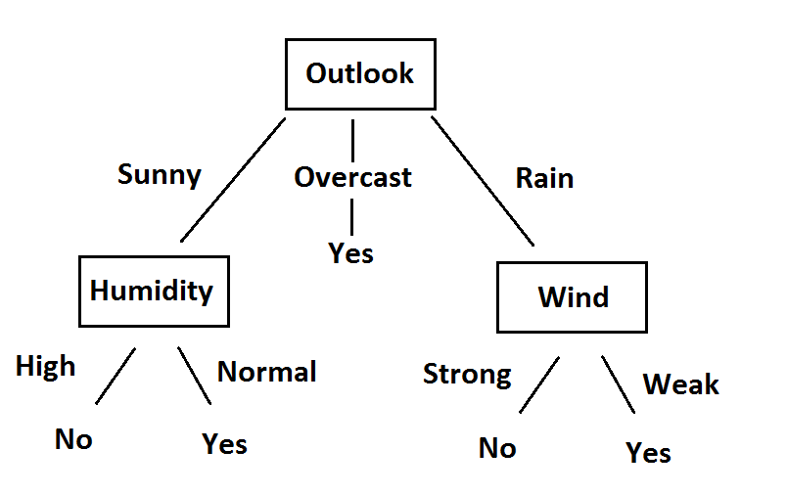Final version of decision tree

